**PROJECT TITLE** :

**To Supply Leftover Food to Poor**

**College Name:** **Rathinam College Of Liberal Arts And Science**

**College Code: NM2025TMID**

**TEAM ID:** 4

**TEAM MEMBERS:** 4

**Team Leader Name:** **C.S.DELPHIN ANGEL**

**Email** : [cs.delphinangel@gmail.com](mailto:cs.delphinangel@gmail.com)

**Team Member1:** **G.NAVEEN**

**Email :** ganeshand947@gmail.com

**Team Member2:** **G.RITHICK**

**Email :** [rithickrithuu25@gmail.com](mailto:rithickrithuu25@gmail.com)

**Team Member3 :MUHAMMED RIYAS**

**Email:** **riyasriyasr262@gmail.com**

**INTRODUCTION:**

In many cities, tons of perfectly edible food are wasted every day while countless people go to bed hungry. This project is aimed at bridging that gap by creating a **Salesforce-based system** to collect, manage, and distribute leftover food from restaurants, events, and households to people in need.

Using the Salesforce platform, we can streamline food donation by managing data related to food donors, collection points, distribution volunteers, and recipients. The platform enables tracking, reporting, and real-time status updates to ensure efficiency, transparency, and accountability.

This application is designed with scalability and social impact in mind and can be extended across multiple cities or regions.

**SALESFORCE DEVELOPER ACCOUNT CREATION :**

Steps to sign up for a free Salesforce Developer account.

* 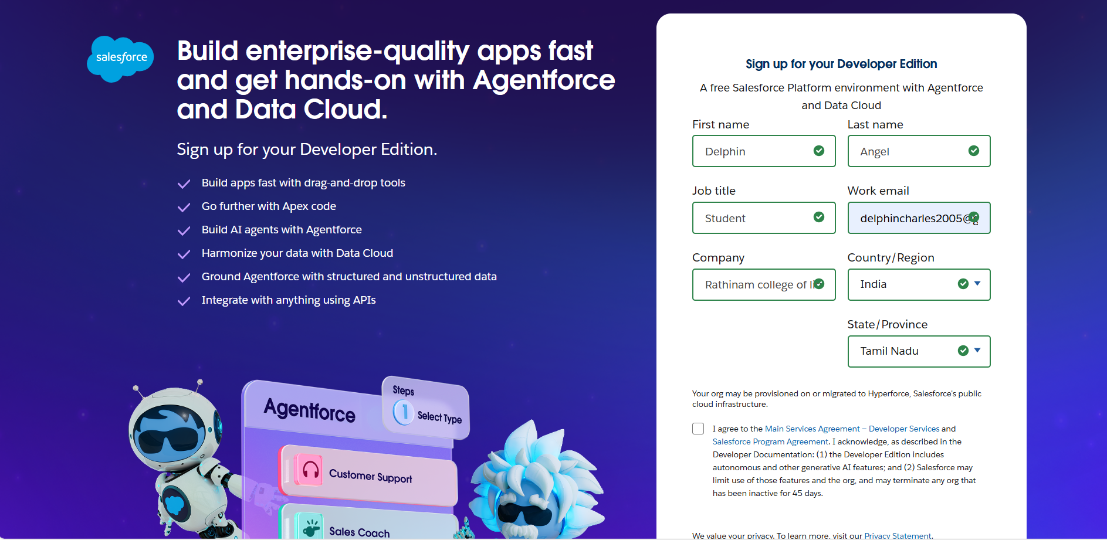

**OBJECT:**

Custom Object: Venue Object, Drop-Off Point Object, Task Object, Volunteer Object, etc.

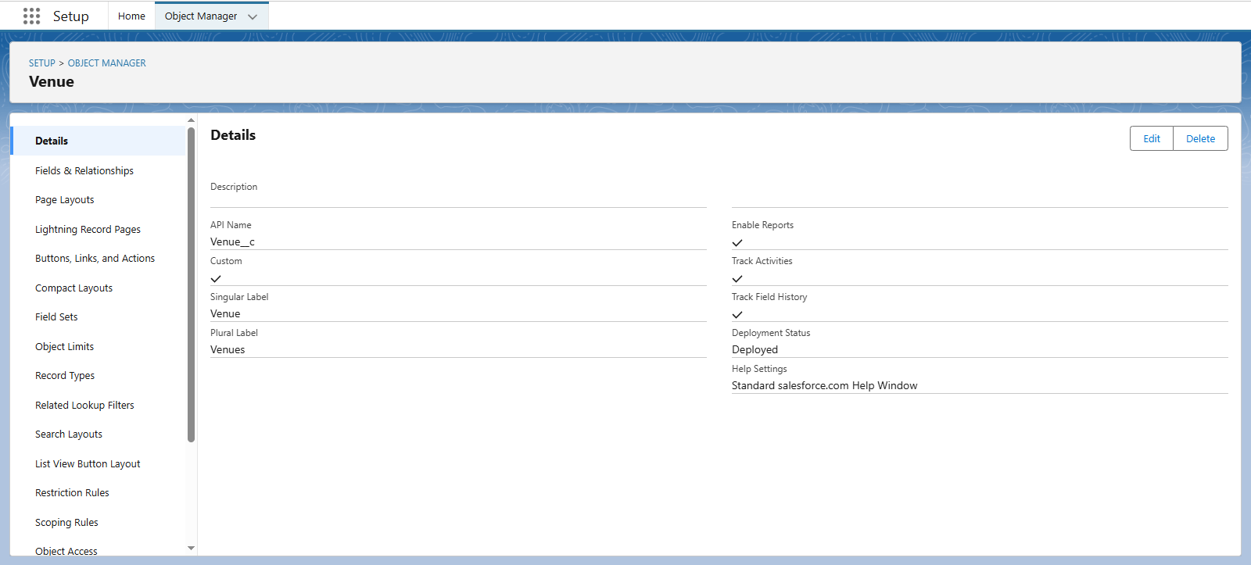

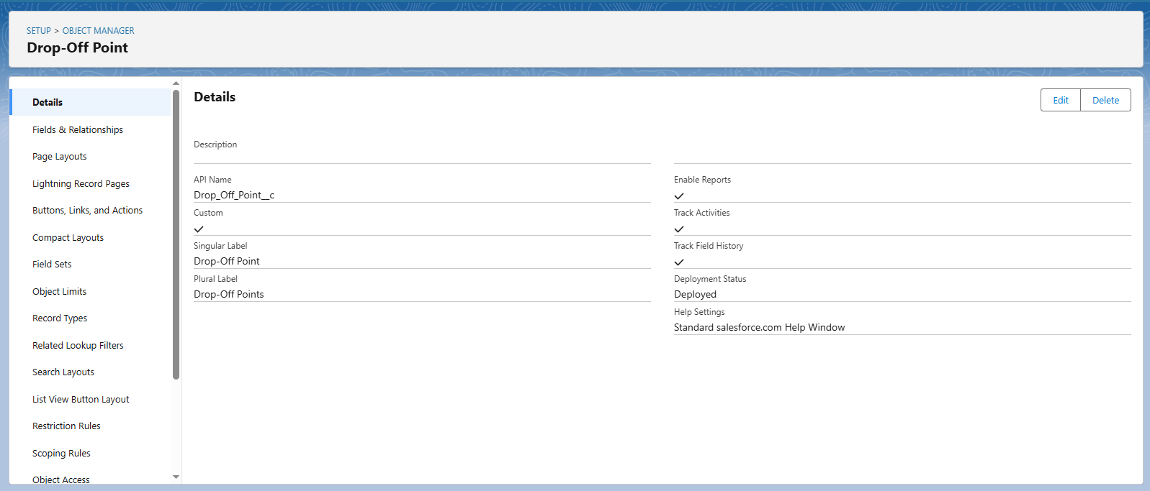

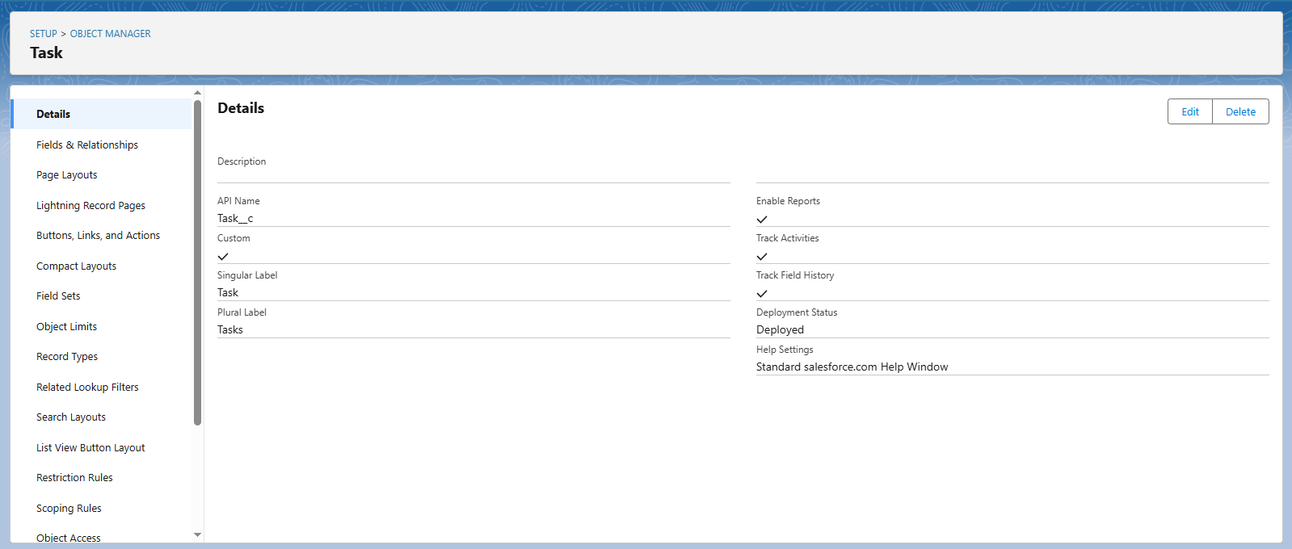

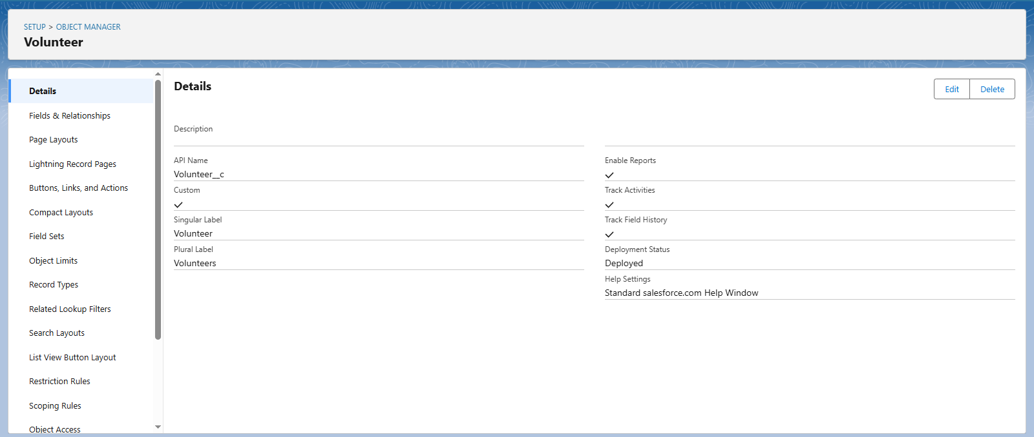

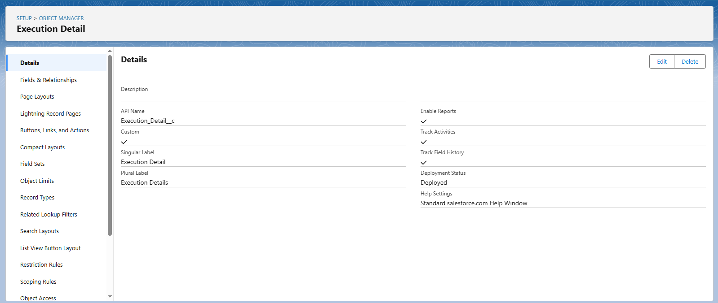

**TABS:**

Creating custom tabs for easy access to the custom objects.

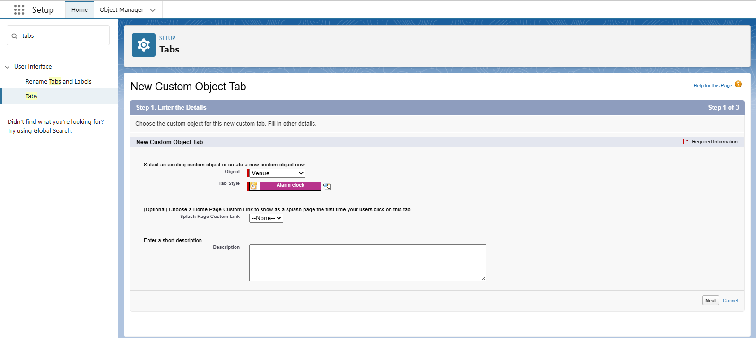

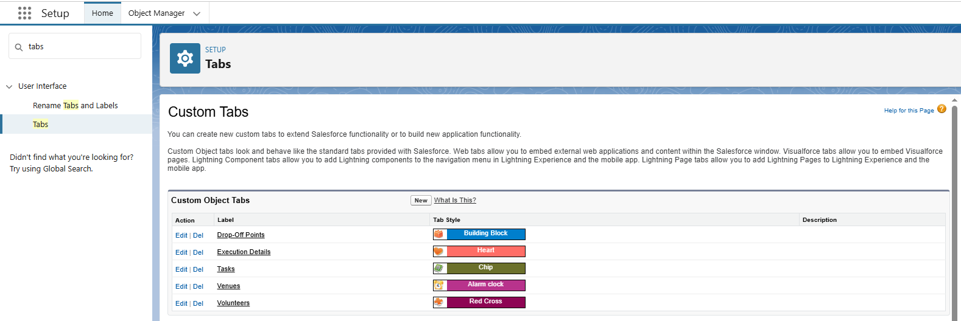

**THE LIGHTNING APP :**

Creating a Lightning App named “FoodConnect” or similar for all components.

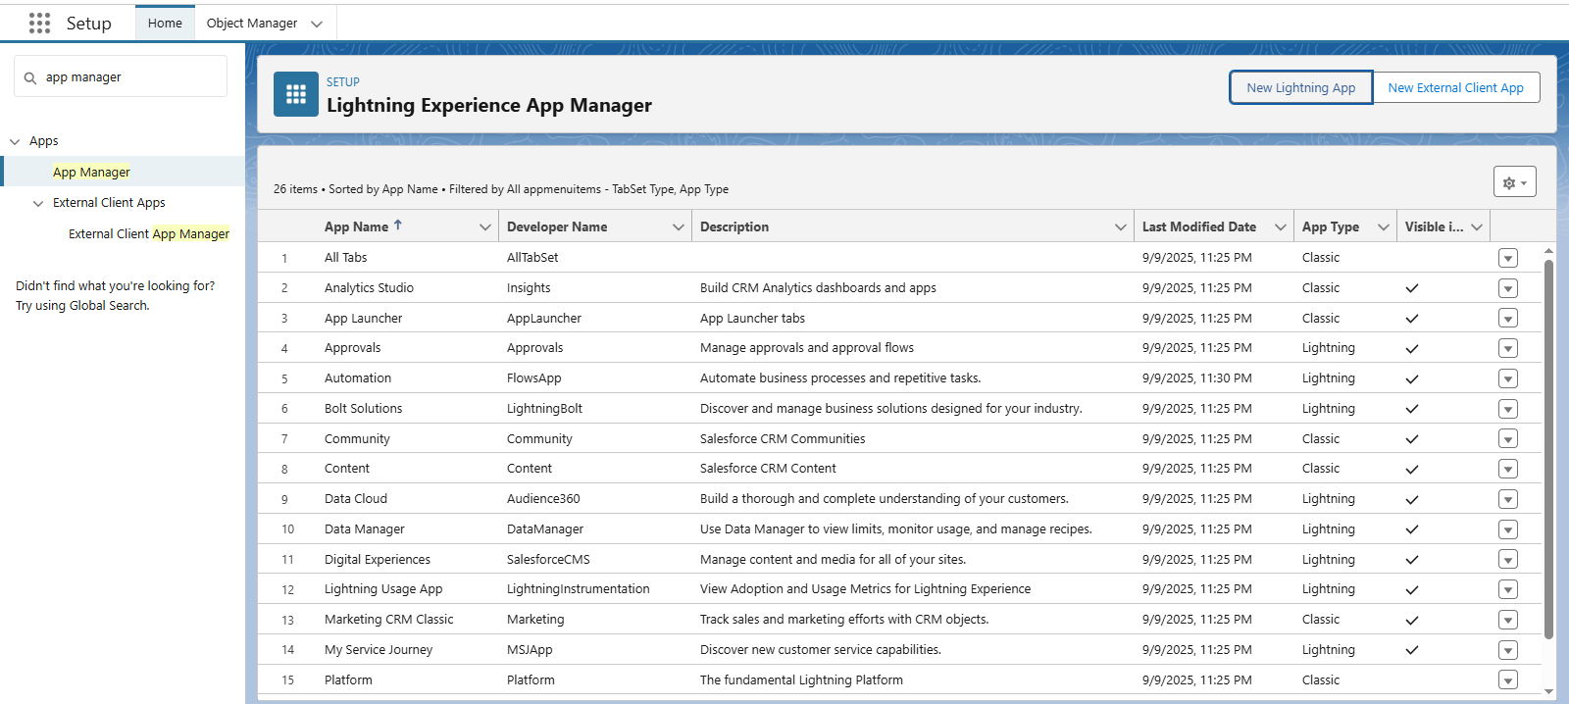

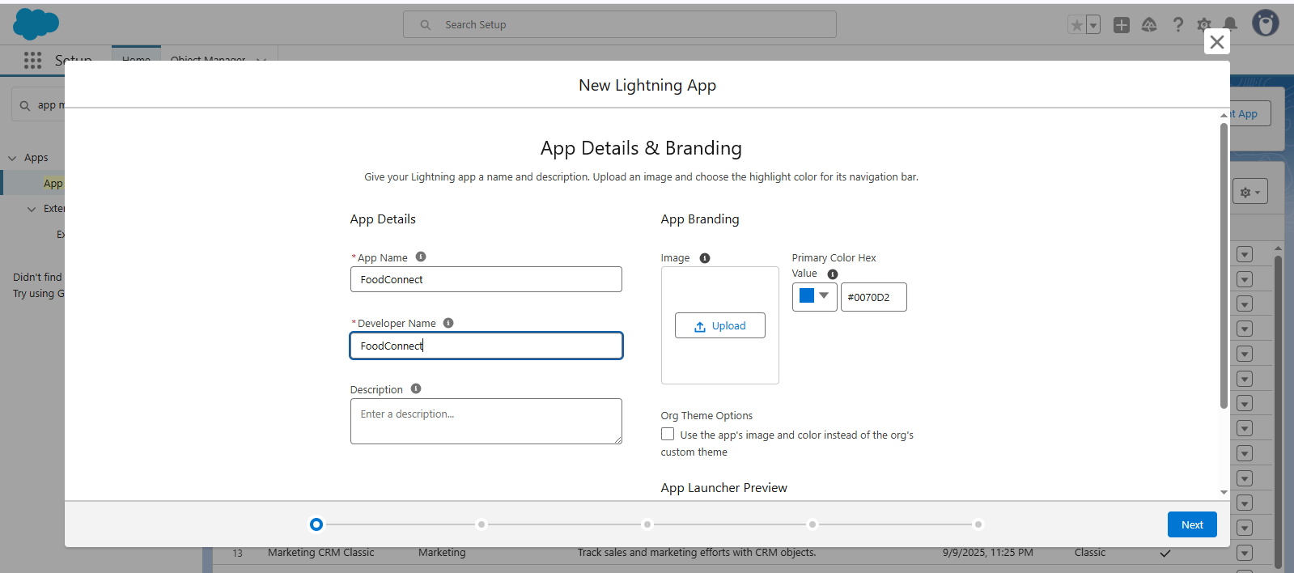

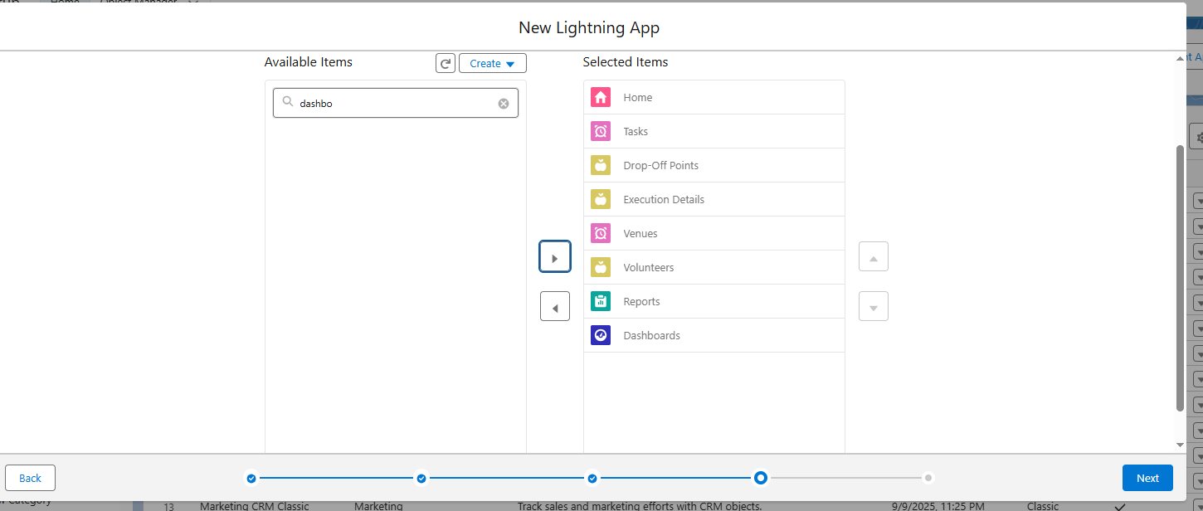

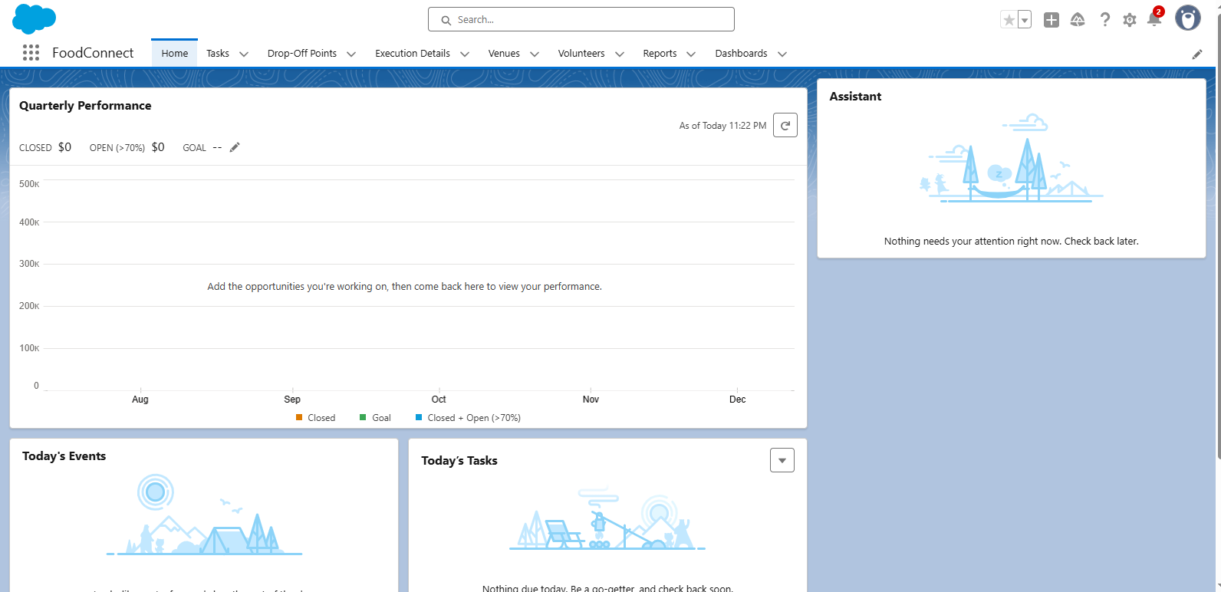

**FIELDS:**

Custom Fields for each object likeVenue object, Drop-Off point object,Task object**,**Volunteer object, etc.

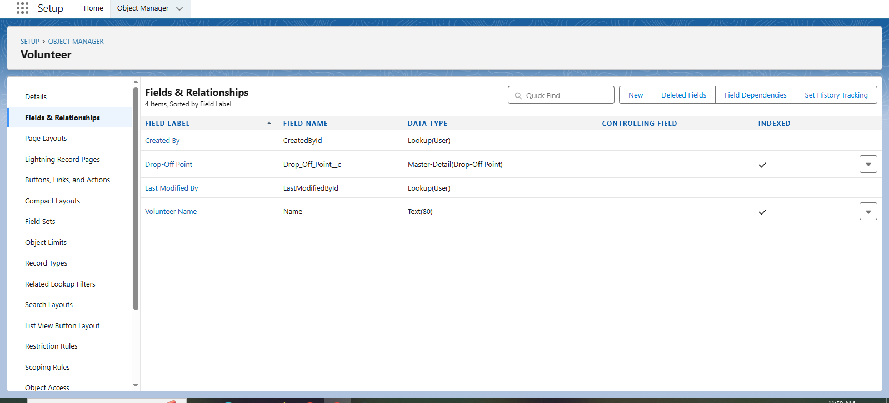

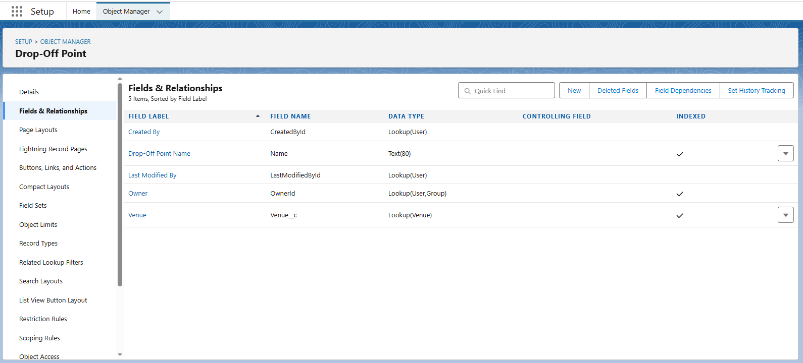

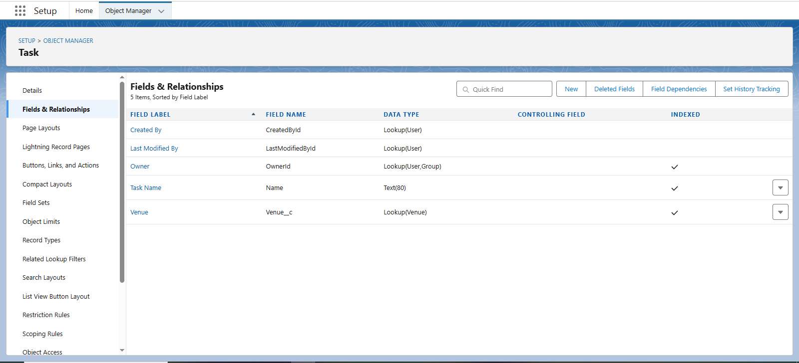

**FLOWS:**

Automating the donation submission and assignment to volunteers.

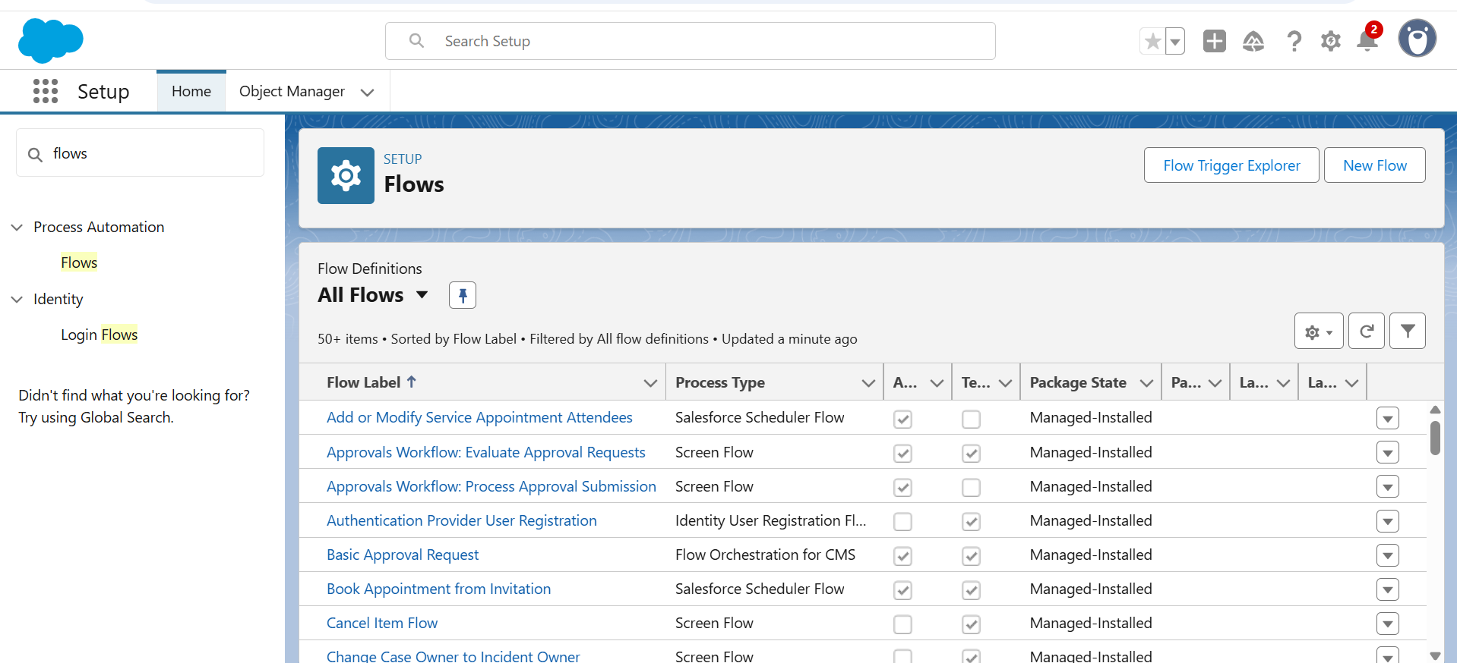

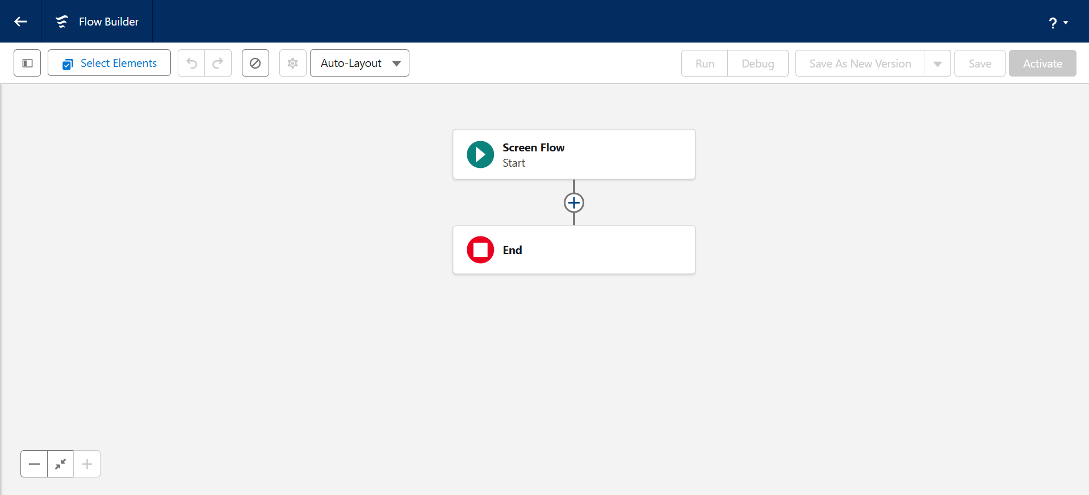

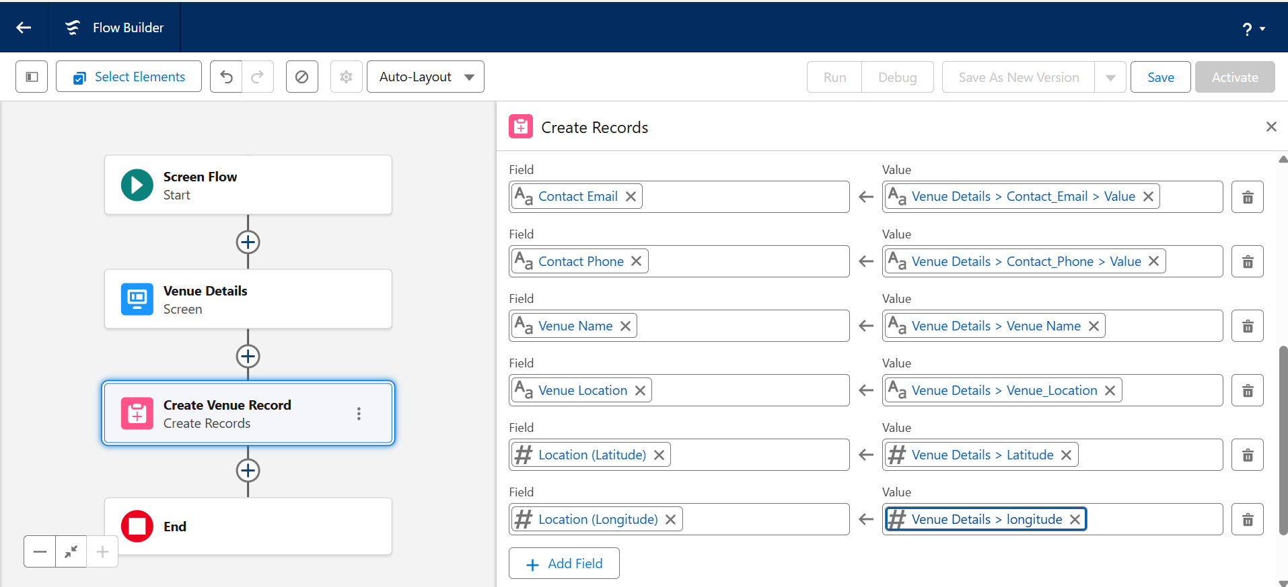

**TRIGGERS:**

Apex triggers to automate specific actions like notifications.

**Trigger Code:**

trigger DropOffTrigger on Drop_Off_point__c (before insert) {

    for(Drop_Off_point__c Drop : Trigger.new){

        Drop.Distance__c = Drop.distance_calculation__c;

    }

}

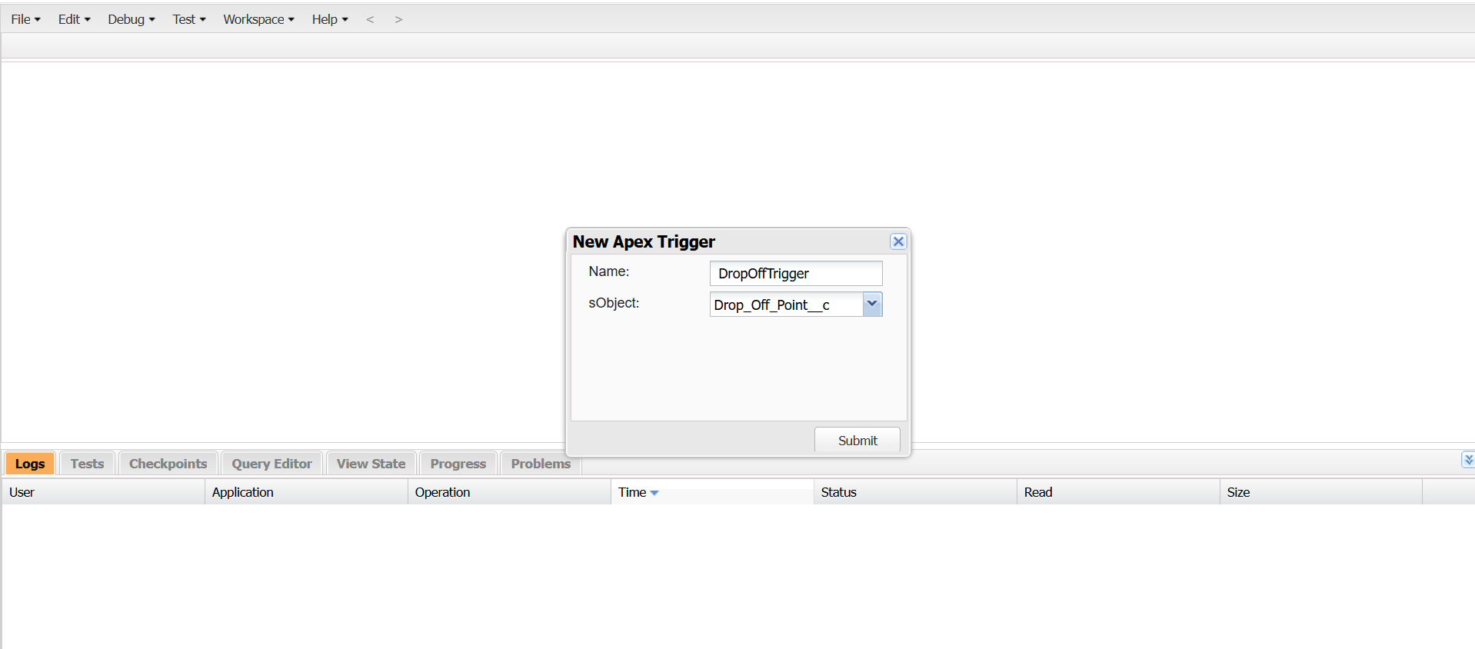

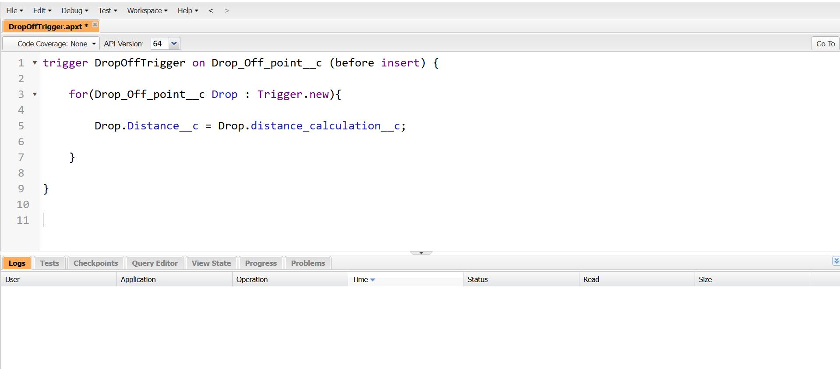

**PROFILES:**

Managing user permissions based on roles (NGOs Profile).

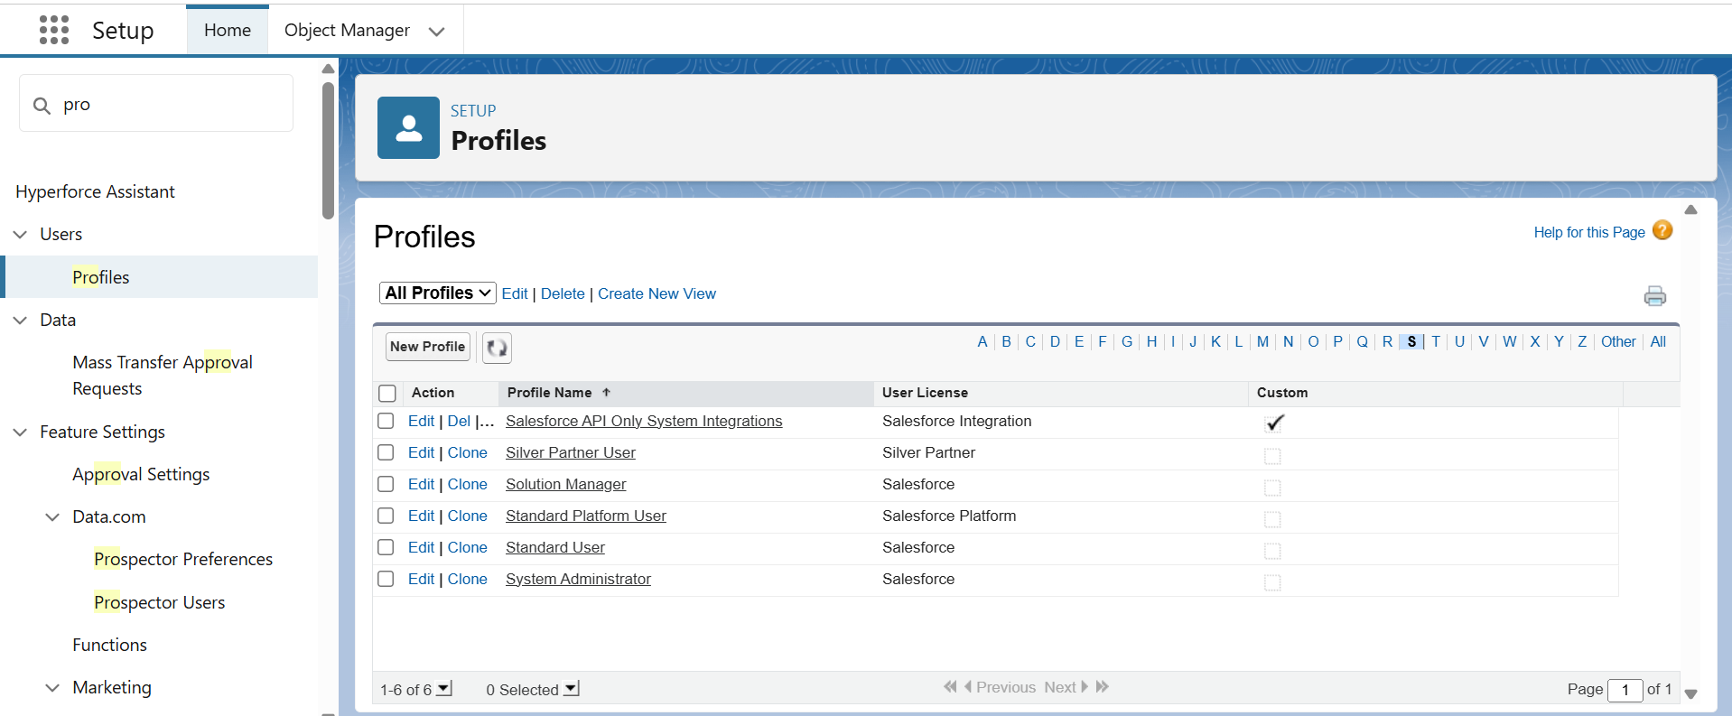

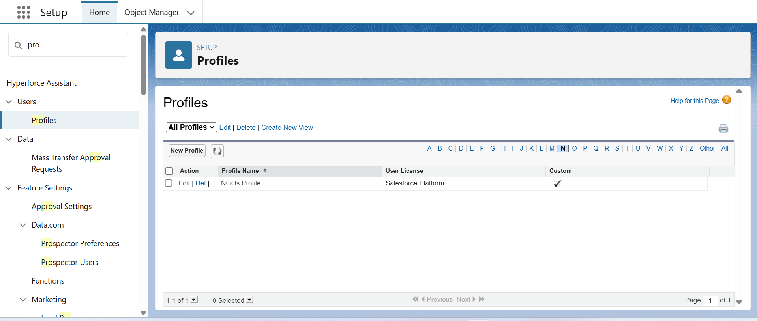

**CREATION OF USERS:**

Creating test users to simulate real-world usage

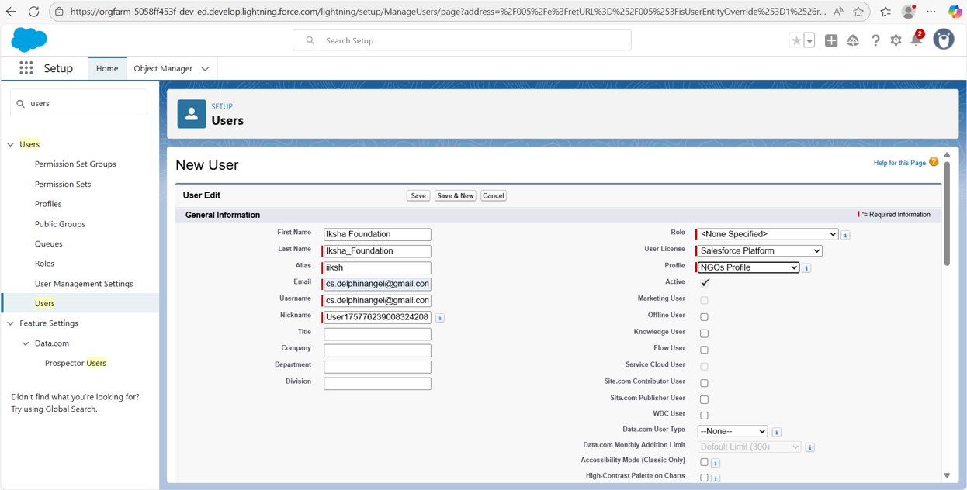

**PUBLIC GROUPS:**

Grouping users for sharing rules and collaboration.

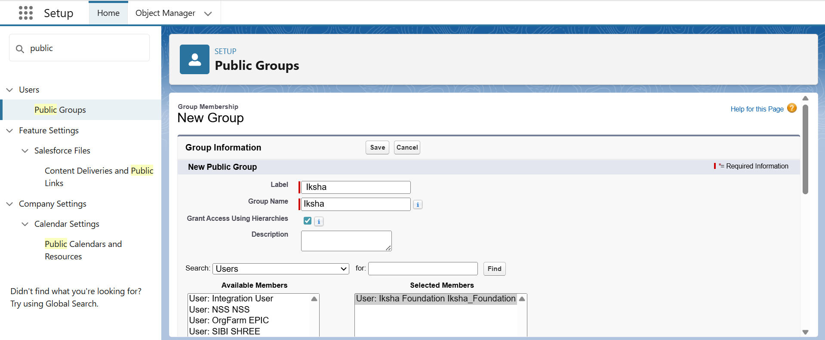

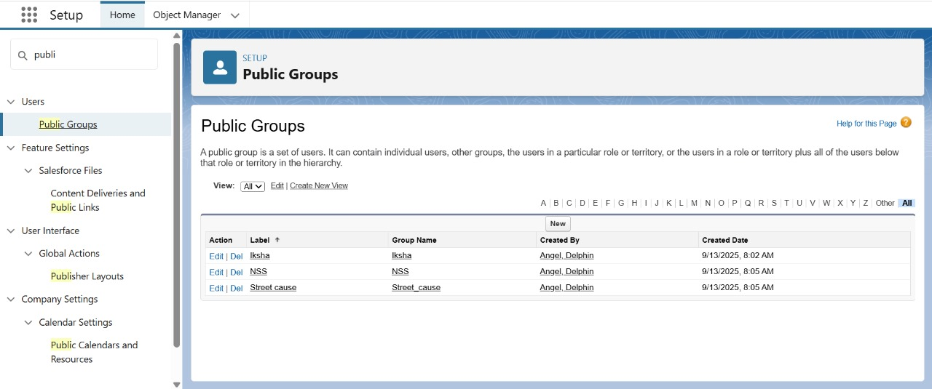

**REPORT TYPES:**

Creating custom report types for data analysis.

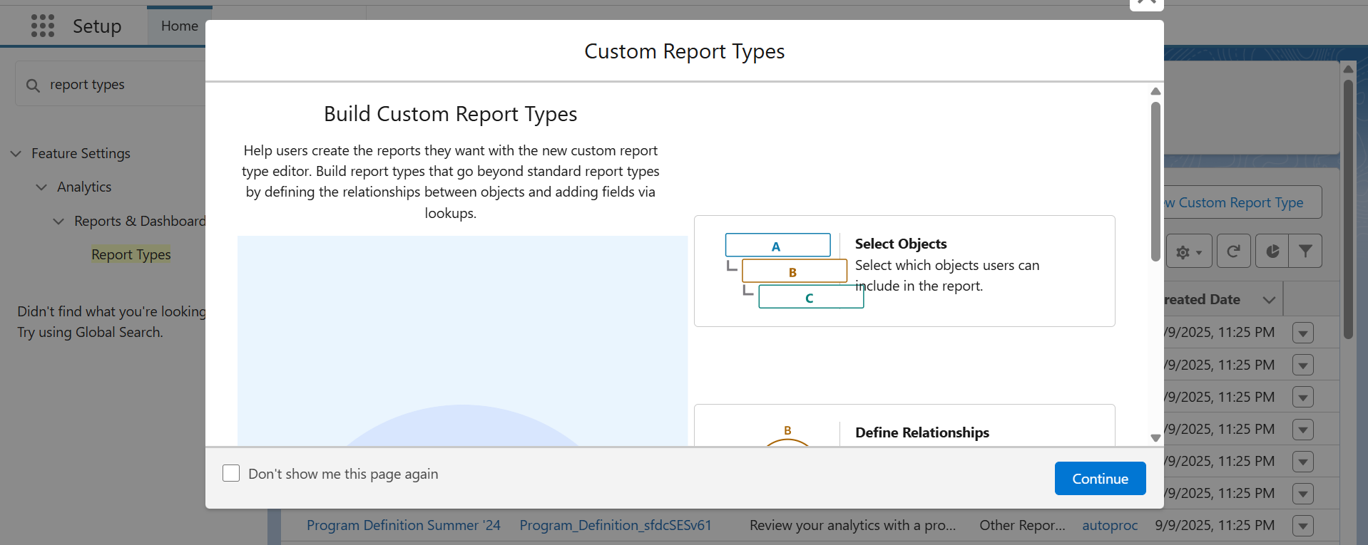

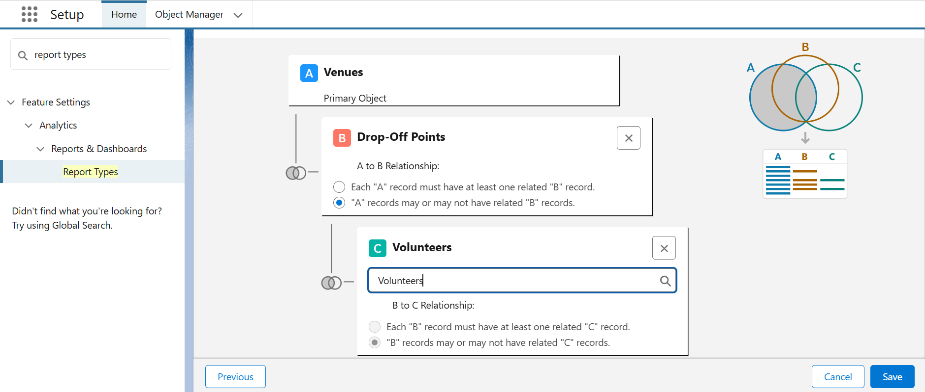

**REPORTS:**

Real-time reports on total food collected, distributed, etc.

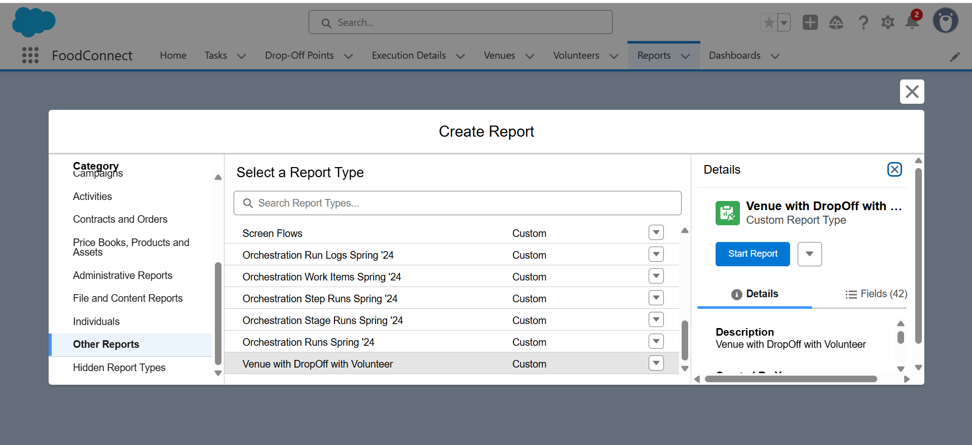

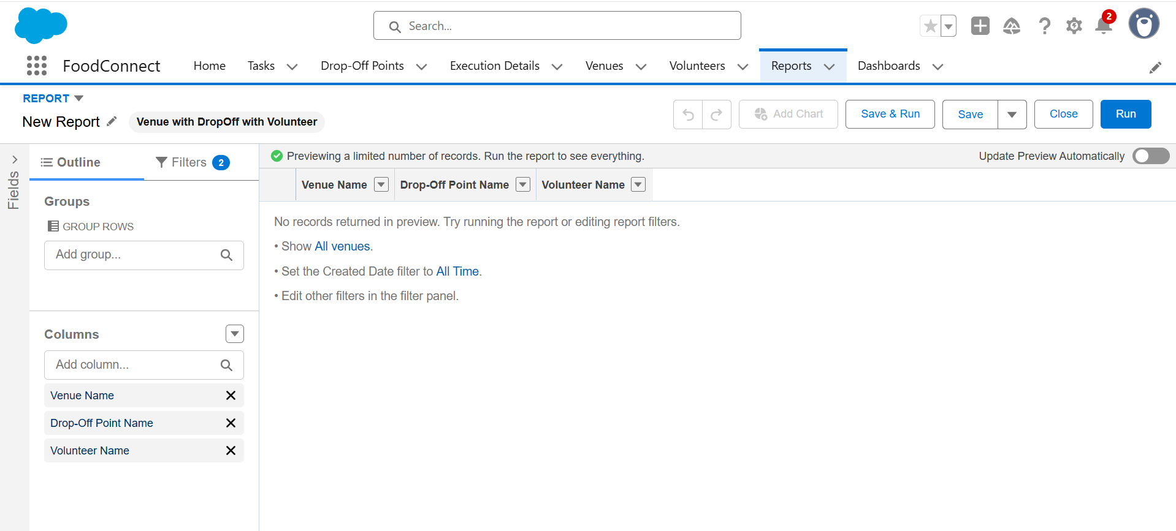

**DASHBOADS:**

Visual dashboards to monitor KPIs like total meals served.

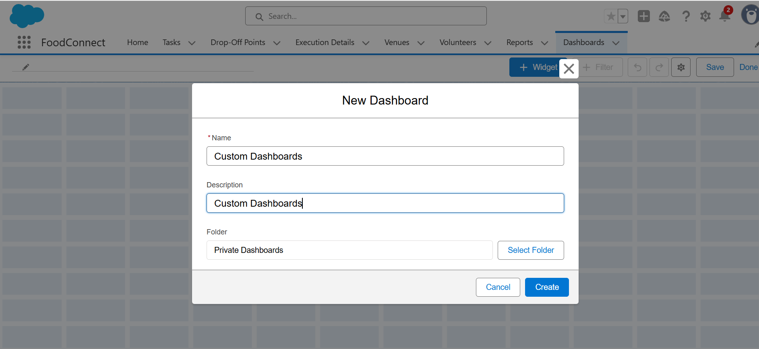

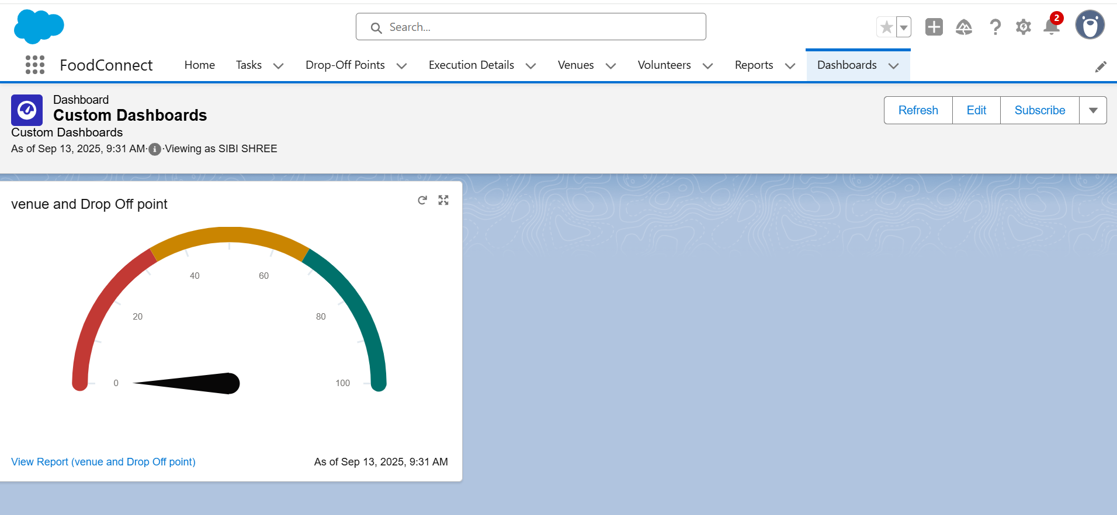

**SHARING RULES:**

Ensuring data access based on user groups.

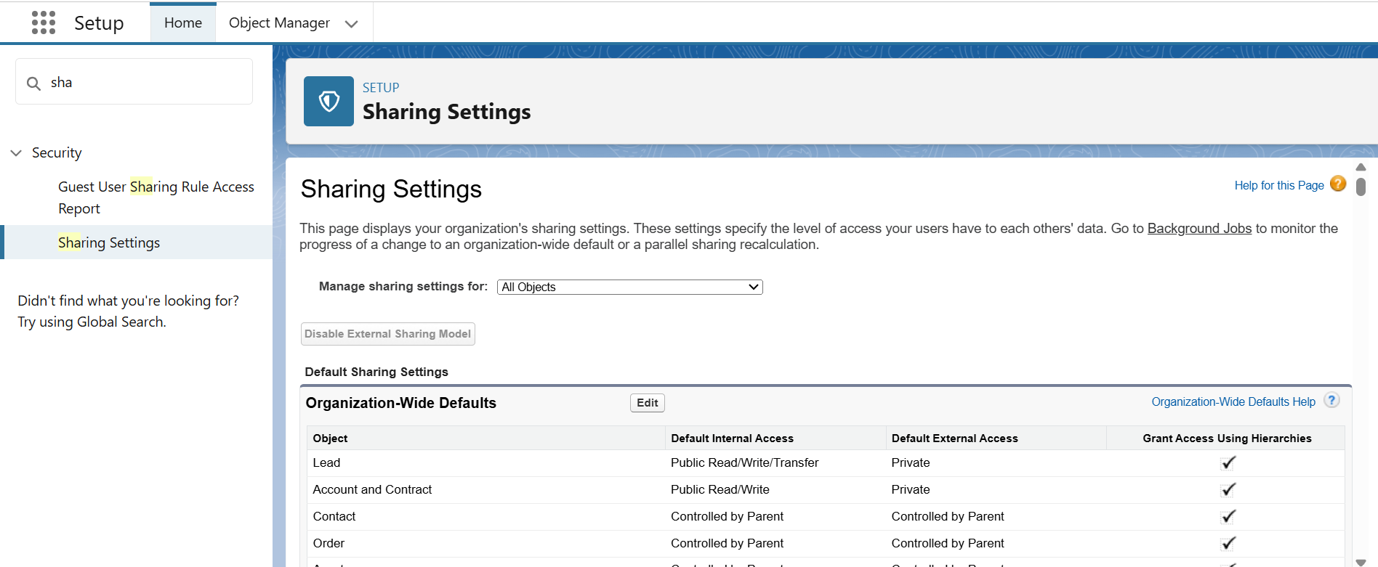

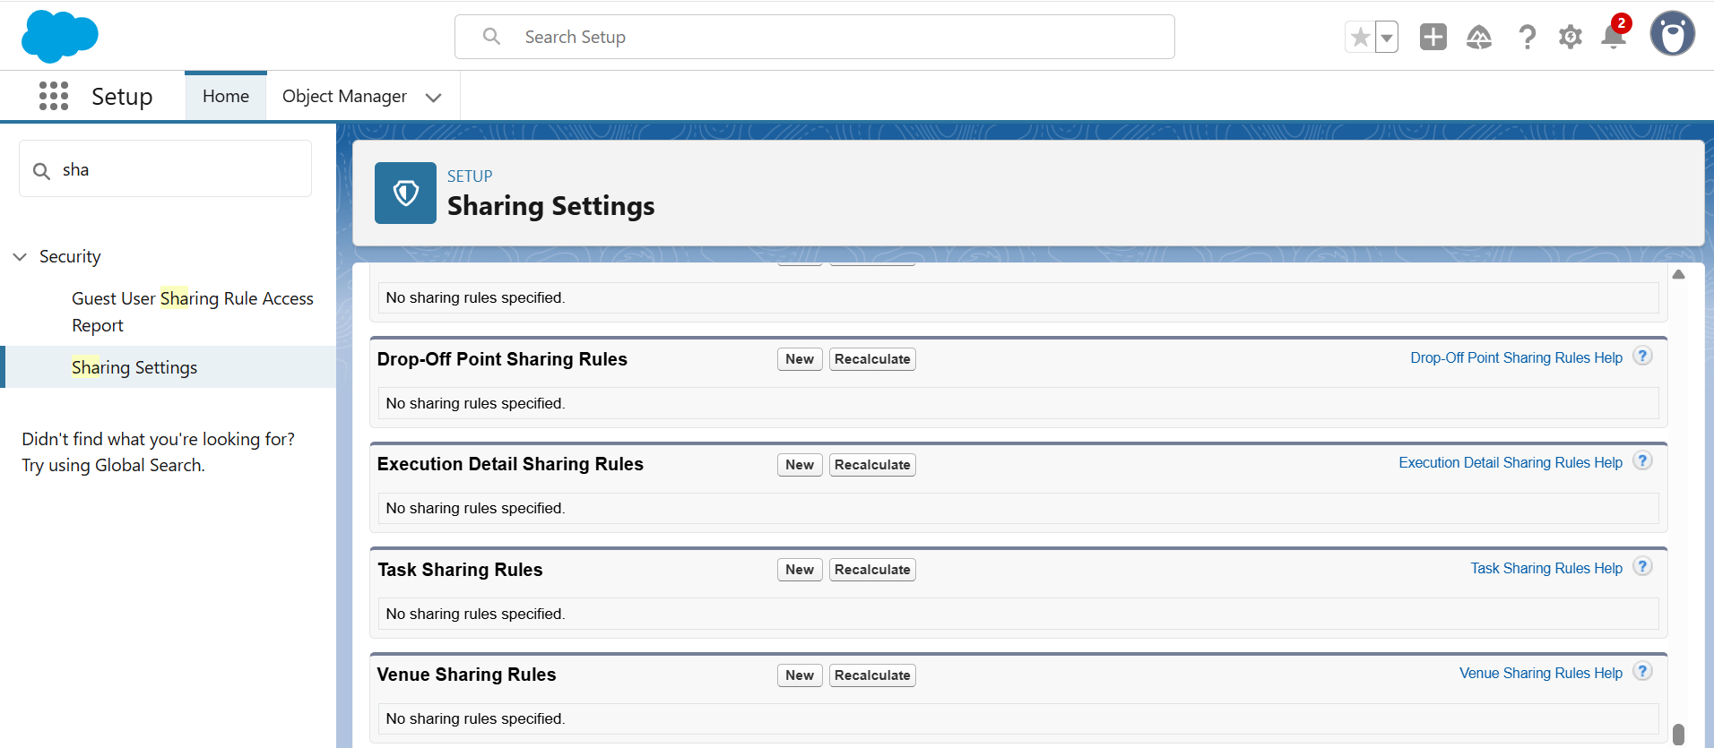

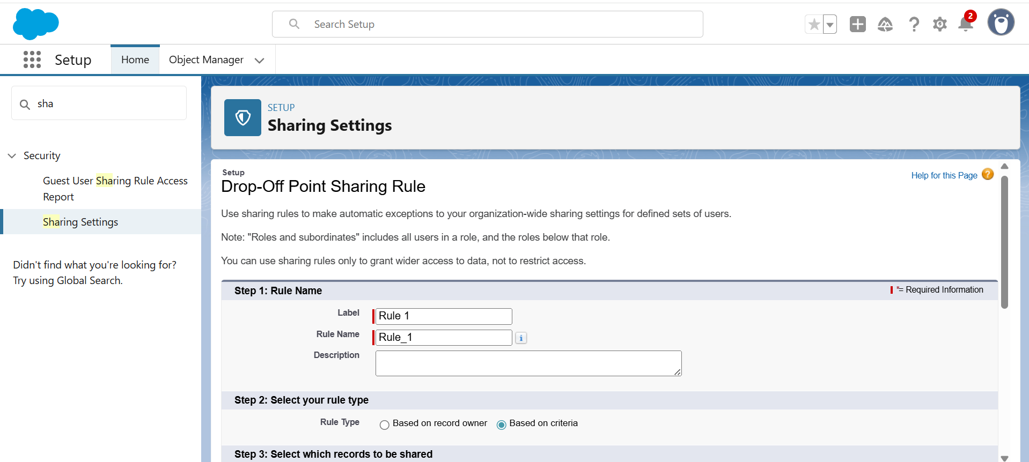

**HOME PAGE:**

Custom Lightning Home Page for users with shortcuts.

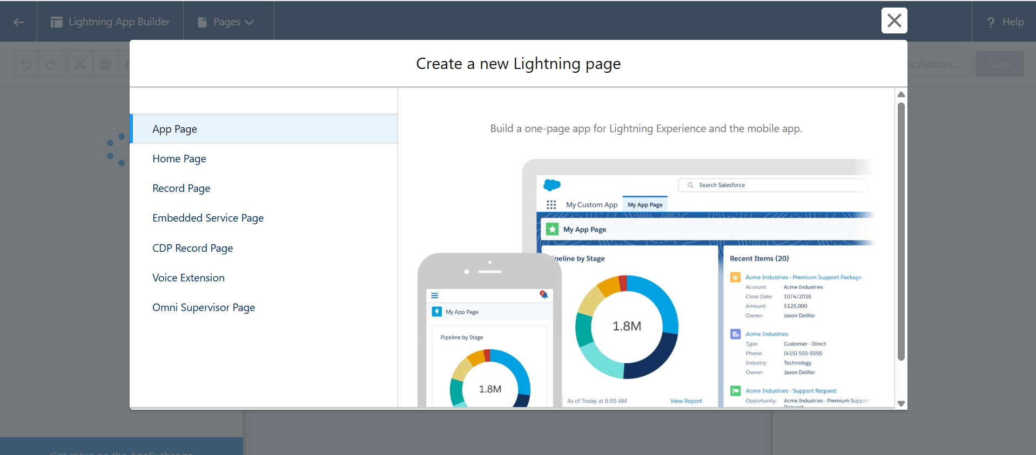

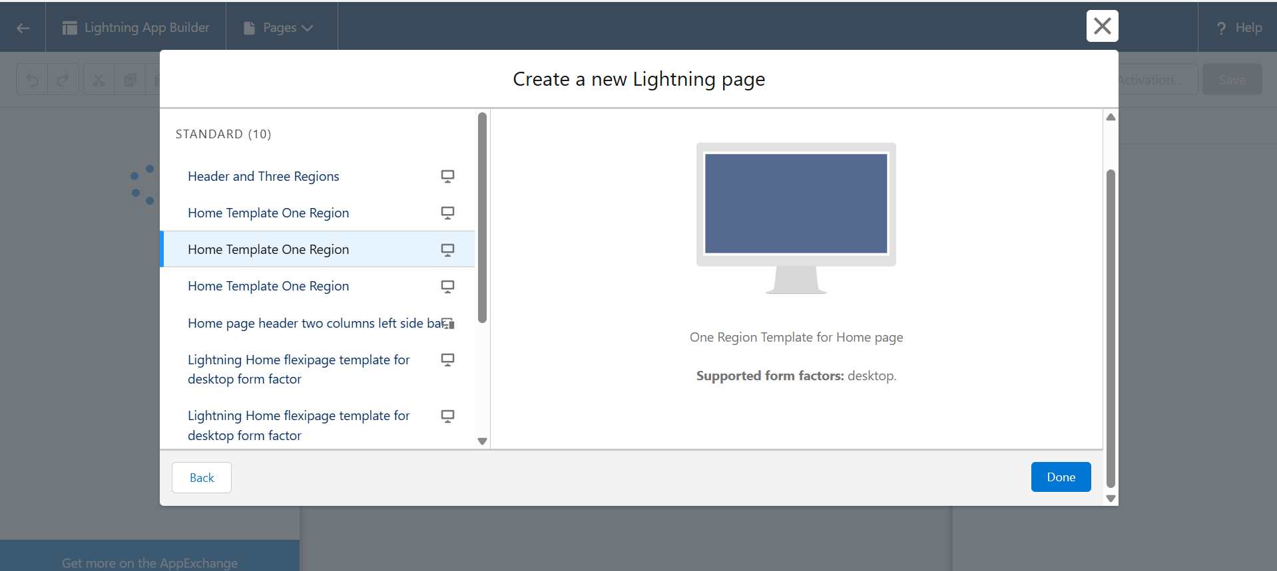

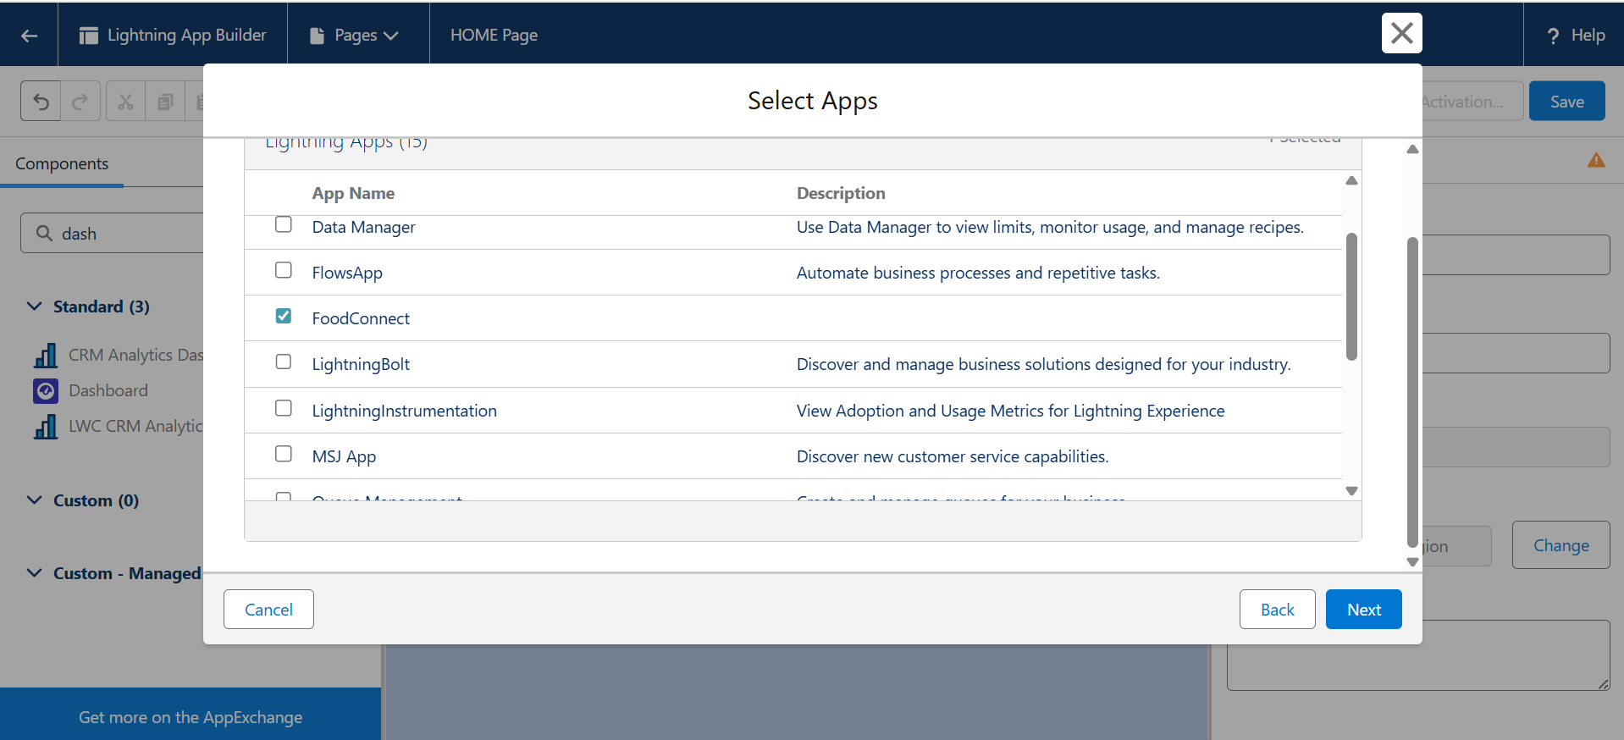

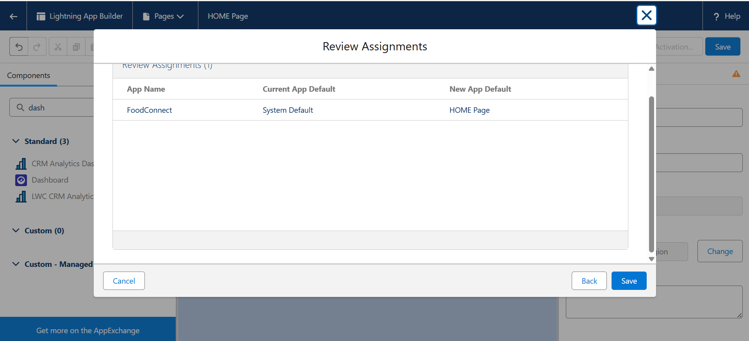

**CONCLUSION:**

By leveraging the Salesforce platform, the project successfully established a streamlined and transparent system for managing surplus food donations. Through efficient coordination with volunteers and timely delivery to beneficiaries, the project effectively addressed food insecurity while maximizing the utilization of available resources.

**OUTPUT:**

